This document is merely to point out the differences in confessional count numbers between my findings and the official numbers posted on Survivor Sucks. The guidelines I use can be found [here](https://docs.google.com/document/d/18ofsPiVWxSejzSjEGlU8KEx4Og2ddEJScCV23RsCPIA/edit?usp=sharing).

**Survivor Sucks Season 25 Counts** ([link](https://goo.gl/photos/Xp6YJyozyU1F3xAH8))

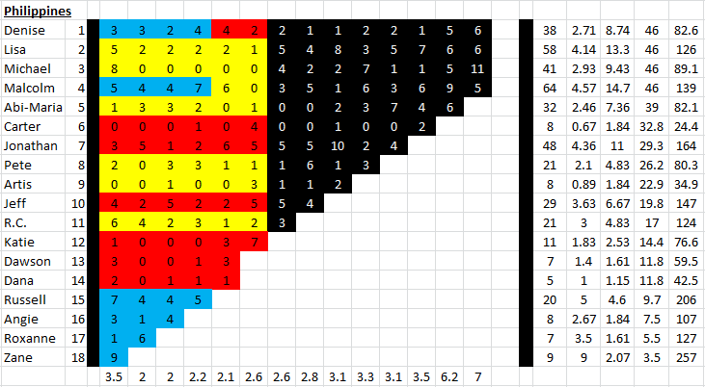

**My Season 25 Counts** ([link](https://goo.gl/photos/o5fMqG39mn3T9phS8))

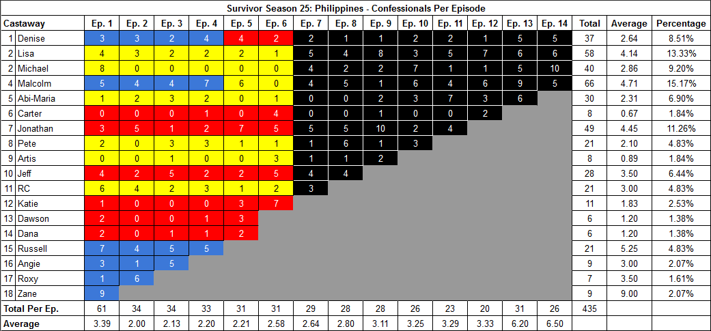

[Survivor Sucks Season 25 thread](http://survivorsucks.com/topic/98727).

**Differences**

[Episode 01](https://docs.google.com/document/d/11WlBqVwX734sxP_KjVVWqPJ9n-O621MXI0t7XUe6yIg/edit?usp=sharing)

* **Lisa: 4 (-1)** Confessional #33 has a 9s gap.
* **Dawson: 2 (-1)** Confessional #31 has a 9s gap.

[Episode 02](https://docs.google.com/document/d/1rNiGVVv_hncm5CzAQoGpaApOmThC7Xi75xe6r_yLemk/edit?usp=sharing)

* **Abi-Maria: 2 (-1)** Confessional #8 has a 9s gap.
* **Lisa: 3 (+1)** Confessional #24 is a voice over.

[Episode 03](https://docs.google.com/document/d/1FIc0po0apmiARmcMaVrFyVfC4YItbWFKtlWi04ETpN0/edit?usp=sharing)

* **Russell: 5 (+1)** Between confessionals #29-30 there is an 11s gap, plus confessional #30 is a voice over.
* **Angie: 5 (+1)** Between confessionals #32-33 there is a 10s gap, plus confessional #32 is a voice over.

[Episode 05](https://docs.google.com/document/d/1U8oauxWS7aUTLDBnQO2y3MSo9j8GDW708ljpLRRB9oI/edit?usp=sharing)

* **Dana: 2 (+1)** Confessional #17 is a voice over.
* **Jonathan: 7 (+1)** Confessional #20 is a voice over.

[Episode 07](https://docs.google.com/document/d/1g4hSYhyCSbXSBC9xpqwrrkYVOKNbkqGu6L8H49TQN4E/edit?usp=sharing)

* **Malcolm: 4 (+1)** Confessional #7 is an on-the-fly confessional.
* **Jeff: 4 (-1)** Confessional #10 has a 9s gap.

[Episode 11](https://docs.google.com/document/d/1hhmS4DjZjGzc9F0czkK5ifQohPhyhoQvbYV8DEYXUEw/edit?usp=sharing)

* **Malcolm: 4 (+1)** Confessional #4 is a voice over.
* **Note:** Regarding confessional #13 Abi-Maria (5/7) - This confessional is broken down in three parts. It starts and ends with confessional interviews. In the middle, there is an on-the-fly segment in which Abi narrates directly to the camera on the jungle. However, this segment, if not included, is over 10s long and would constitute a new confessional for Abi if it weren’t included. Also to note, in order for Abi to have the same count of 7 as it was originally counted for this episode, this on-the-fly segment has to be included. Breakdown of confessional:
  + This morning, I woke up, and I woke up very ambitious. I woke up with a feeling that I am not gonna go without fighting. (17:08 → start of on-the-fly segment) They were having a lot of problems with me being such an honest person, blunt person. They asked for this. Now it's time for me to lie. I'm gonna outplay them. (← 17:21 = 13s | end of on-the-fly segment) I will be creating a fantasy fourth Hidden Immunity Idol.

[Episode 12](https://docs.google.com/document/d/195GVunXTA-gFatoqNBKW0hufmqXKm54tiP6WQnamF-k/edit?usp=sharing)

* **Abi-Maria: 3 (-1)** Confessional #2 has a 9s gap.

[Episode 14](https://docs.google.com/document/d/1etJBPwz8Xl_QVD7lXatmC9Adf2BbMqNF0CJfqZyFALI/edit?usp=sharing)

* **Michael: 10 (-1)** Confessional #23 has a 9s gap.
* **Denise: 5 (-1)** Confessional #24 has a 9s gap.

**No Change**

* [Episode 04](https://docs.google.com/document/d/1aqpPUjVAfQgvFriEI4urWdYA0Yo8GNuqXQIuuPsa1gk/edit?usp=sharing)
* [Episode 06](https://docs.google.com/document/d/1EBb8iJbXpF9JEuT4VQpyuopKdnFsGYnhl487or2VWsE/edit?usp=sharing)
* [Episode 08](https://docs.google.com/document/d/1bLIqvUbHOXbtCFTiAyqCrOQiqsuGcHBZGLNBsk487RY/edit?usp=sharing)
* [Episode 09](https://docs.google.com/document/d/1Q11mwN3kOXSHu0PM3FjkUIV_8mOMS9SaujrMcwUIaG8/edit?usp=sharing)
* [Episode 10](https://docs.google.com/document/d/1FU1fWx8O3IUhQTj4_hBZqJBBgeE34TIn7nWqjbuhsq8/edit?usp=sharing)
* [Episode 13](https://docs.google.com/document/d/1VVD6axT4NFijDZZ3NkD49PqTmsBUa8dtgjpVZHCSaeI/edit?usp=sharing)

|  |  |  |
| --- | --- | --- |
| **Castaway** | **Count** | **Change** |
| Angie | 9 | +1 |
| Russell | 21 | +1 |
| Dana | 6 | +1 |
| Dawson | 6 | -1 |
| Jeff | 28 | -1 |
| Jonathan | 49 | +1 |
| Abi-Maria | 30 | -2 |
| Malcolm | 66 | +2 |
| Michael | 40 | -1 |
| Lisa | 58 | - |
| Denise | 37 | -1 |
| **Total** | **435** | **-** |

**Revised Sucks Counts** ([link](https://goo.gl/photos/WNZgHSa5G4c4UwpG9))

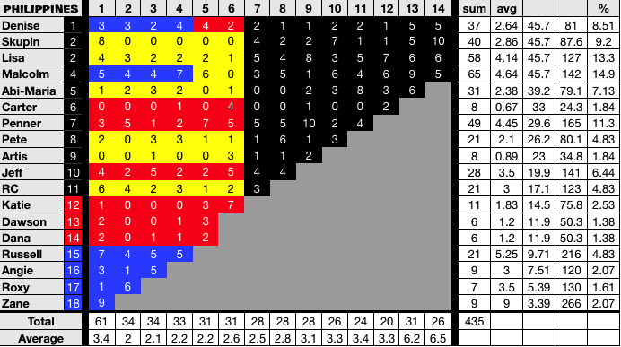

**Differences:**

* Ep. 7 - Malcolm’s on-the-fly confessional #7 was not counted.
* Ep. 11 - Abi-Maria’s confessional #13 had an on-the-fly segment which was not taken into consideration and thus created an additional count for her.